**Automated 35mm Slide Digitizer Manual**

May 30, 2021

# Introduction:

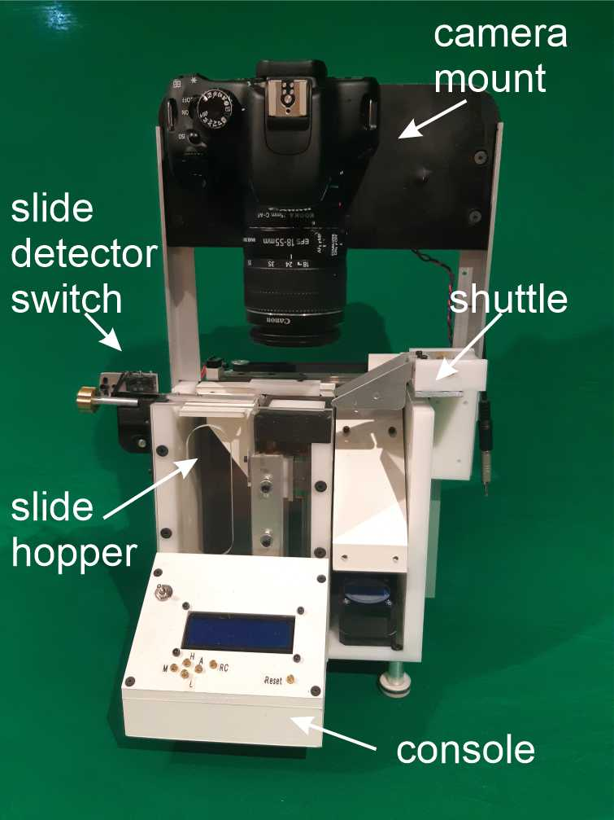This machine will scan 35mm slides to a digital camera. It was designed to fit a Canon Rebel T2i camera with a 25mm macro extension tube[[1]](#footnote-1). Using this camera, a 35mm slide nicely fills the field of view of the camera. A different camera would also work, but the location of the hole may not be correct for that camera and macro extension. Some experimentation might be needed to make a different camera work. In operation, the scanner picks up one slide at a time, moves it above a little light box in front of the camera, takes a photo and stores in on the camera’s SD card and then moves the slide to the opposite side where it dumps the slide. This little document will explain how to use the scanner.

# Scanner Parts:

The slides scanner main components.

There are four main sections of the slide scanner: Slide Hopper/Elevator, Elevator Limit Switch, Slide Shuttle and Console Box.

## Slide Hopper:

This is a vertical chute into which slides are loaded. At the bottom of the chute is the “slide elevator” which rises to introduce slides into the machine one at a time.

## Slide Detector Switch:

This is a little switch which is situation at the top of the slide hopper. This detects the presents of slides in the hopper. It is a delicate device and it is use to make fine adjustments to the system. It has two positions. As shown in the figure here it is in the “Closed” position where the limit switch tang is covers the slide hopper and can detect slides. In the “Open” position, the switch is rotated counter-clockwise (when looking at the consoled) to a retracted position which allows access to the top of the hopper for loading slides into the hopper.

## Shuttle:

This is the transport device which moves the slide from the top of the slide stack while in the hopper to the light box for photographing and then off to the opposite wide where dumps it when finished. When done this cycle, the transport device returns to the hopper to get the next slide.

## 20200529_120059.jpgConsole:

This carries the buttons and microprocessor to operate the slide scanner. There are 6 buttons.

“M” stands for Manual. This allows scanning one slide at a time. It is also useful for focusing the camera for the first shot.

“A” stands for Automatic. This initiates scanning of all slides in the hopper automatically.

The digital controller and buttons.

“H” stands for Home. This tells the scanner to find its start position.

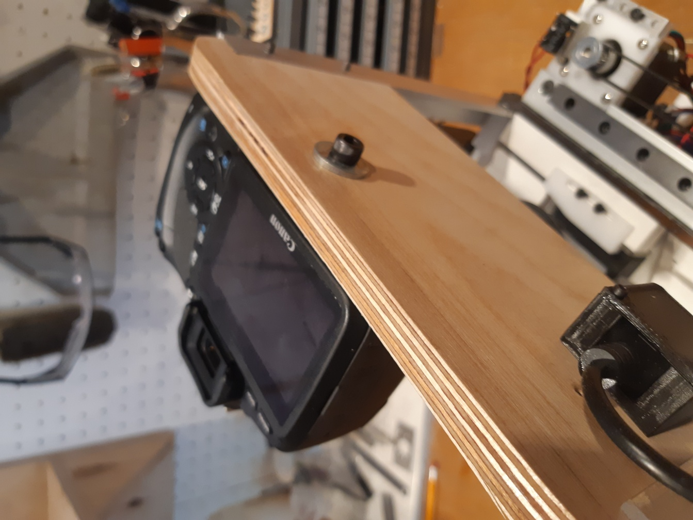“L” stands for Load. This drops the hopper elevator to permit loading of slides.

“RC” stands for Retract/Close. This is used during the loading of slides.

“Reset” is used to stop the scanner and return to a default condition. It is kind of an emergency switch which can be used should the scanner malfunction or a button was accidentally pushed out of sequence.

# Assembly:

First mount the camera onto the camera plate with a ¼-20 Allan screw provided. There is another one in the box with a bigger screw head which also works. There is a 2.5mm phone jack which should be plugged into the camera release trigger port. Do NOT plug this in before turning on the camera. This won’t hurt the camera but I’ve found that plugging it in after you have turned on the camera permits display of camera settings in the ‘Display’ mode.

Mounting the camera with a ¼-20 bolt.

# 20200529_120043.jpgTurning on the Scanner

First, power the scanner using the 9 Volt wall power supply which came in the storage box. This is plugged into the circuit board on the back of the scanner using a 3.5mm barrel connector on the circuit board as shown. Toggle the little switch on the console to turn on the scanner. After a few seconds a little greeting will appear on the LCD. It will then suggest that you home the scanner. Press “H” to do this.

The plug to power the slide scanner

# Setting up the Camera:

If this is the first time you’ve used the scanner, you need to adjust the camera white balance as well as its centering and focus. Turn on the camera. You will see that the shuttle is partially covering the light box so that you can’t see it clearly through the camera view finder. To move it out of the way, simply press the “RC” button. The shuttle will move so that you can now see the light box in the camera view finder. You can now establish the white balance. You do this by taking a picture of the light box WITHOUT A SLIDE. Once you’ve done this, you can now establish the white balance for the camera. You will need to consult the manual for your camera to set the white balance. For example, for the Canon T2i the information can be found at:

<https://www.cameraexperts.us/canon-eos-rebel-t2i-550d-pictures/setting-the-white-balance.html>

Once the white balance and camera focus has been done, ***press RC again*** to return the scanner to its home position. Now that you’ve got the proper white balance, you need to focus the camera and make sure that the camera view is centered on the slide. To do this, we need to LOAD some slides into the slide hopper which is described next.

# Loading Slides:

There are five steps to load the scanner with slides.

Step 1: - RETRACT the shuttle. This is done by pressing the “RC” (for retract/close) button. The shuttle will move away from the home position and expose the hopper.

Step 2: - ROTATE the slide detector switch away (counter clockwise) from the hopper opening. This limit switch is delicate and the heart of the system. **Do not grab it by the metal tang** but by the body of the switch. Pull it to the left and it will rotate away from the hopper opening.

Step 3: -LOWER the elevator to make space for slides. This is done by pressing the “L” (for lower) button. This will drop the elevator a few centimeters to allow the slides to be dropped into the hopper opening. Insert slides with the long dimension of the slide image so that it has the same orientation as the white panel in the light box. Once you have added some slide and if you want to add more slides, 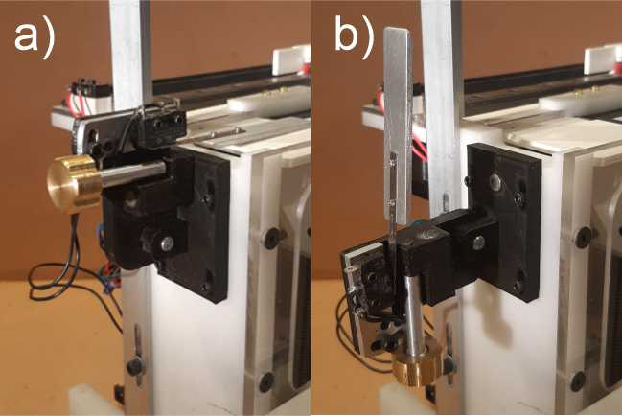press L again which will cause the hopper to drop further. This can be repeated until you’ve loaded all the slides you want. Typically, this will be a complete box of slides of up to ~40 slides. When you’ve loaded all the slides go to Step 4.

The slide detector switch shown in the closed (a) and open (b) positions. This lifts the switch tang off the hopper elevator to allow access to put slides into the hopper. The brass knob is used to adjust the point where the hopper reaches “home”. Don’t grab this by the tang or the knob but rather the body of switch or frame. It is held in place with a magnet when returning the closed position.

Step 4: ROTATE the slide detector switch back to the closed position which covers the slides with the metal tang. This permits the system to detect when the top slide is aligned with the shuttle mechanism. This is an important….. DO NOT MISS THIS STEP.

Step 5: -Home the shuttle. This is done by pressing the “RC” button again. This will move the shuttle to the home position and is now in a position to grab the first slide in the hopper. This will be composed to two motions. First the slide hopper will rise until the limit switch is triggered. This aligns the top slide to the shuttle claw. Second the shuttle will move so that the claws are just the left side of the top slide to capture it.

# Focusing and Centering the Camera

At this point, you will now have a stack of slides in the slide hopper ready to be scanner. However, if this is the first time you’ve used the scanner, we must complete two more things. We need to focus the camera and make sure that the camera is centered on the slide. This involves two steps.

Step 1: - MOVE a SLIDE onto the light box: We need to put a slide above the light box so that you can see it in the camera view finder for focusing. To deliver a slide to its photo position, press the “M” (for manual) button. This will cause the scanner to capture the top slide and move it onto the light box. The slide will stay there. Now look through the viewfinder of the camera and adjust the focus. Use manual focus as you only need to focus the camera once. As long as you don’t touch it again, it should remain focused for all the slides from this point forth. Once you have focused the camera, you should make sure that the camera is centered on the slide in the left-right direction. Loosen the ¼-20 bolt you used to mount the camera and adjust the camera angle to get the whole slide centered. You might also need to adjust the focal length/zoom of the lens. Once done, you shouldn’t need to adjust this again. You’ve now finished setting up the camera.

Step 2: - DUMP the slide. Press the “M” (for manual) again. This will move the slide further to the right and dump it after which the shuttle will return the home position. You will need to add this slide onto the stack to ensure that it gets scanner. Use the LOAD SLIDES operation to do this or just add it to the next batch of slides during the next loading phase.

At this point you’ve now loaded slides, set up your white balance, focused and centered the camera. You are now ready to start scanning. Having done this for the first slide, you won’t need to repeat this again as long as you don’t adjust the camera geometry.

# Scanning Slides Automatically

At this point, the scanner essentially runs itself. Just press the “A” (for automatic) button. The scanner will do a repeated cycle composed of:

1. Capturing a new slide,
2. Move it to the photo position over the light box
3. Taking a picture
4. Move to slide to the “dump” position and
5. Returning the shuttle for the next slide.

This will continue until there are no more slides in the hopper. The scanner has been calibrated to know when the hopper is empty. However, sometimes it might not trigger at the right point in which case there might be a couple of slides left in the hopper. If this is the case, scan these remaining slides using the “M” button to scan each slide manually until the hopper is empty.

# Reloading More Slides

Now you have scanned one box of slides. To do the next box, load more slides as outlined in LOADING SLIDES and repeat until you have done all your slides.

# More Subtle Stuff

The scanner was designed to be able to scan all possible 35mm slides. Unfortunately, slides are not identical. For example, paper slides are about 1.1 mm thick, while slides mounted in plastic holders are about 1.3mm thick. To make matters more annoying, paper slides can warp and can also swell. So that 1.1mm dimension can vary. I’ve noticed that paper slides seem to swell differently depending on the advertising embossed on the slide. So, in practice, I have found that paper slides are more troublesome to scan than plastic ones. When loading the slides into the hopper, have them oriented in the same manner for each slide. For example, if there is printing on the slide, have the printing arranged in the same way for each slide in the stack. In general plastic mounted slides are a little less troublesome as they don’t warp. However, these can be held together with little plastic rivets that can protrude a bit from the surface of the slide. The best thing to do for these slides is to follow the same rule for the paper slide by arranging them in the same orientation. However, if the slides are getting jammed going through the scanner or this is the first time you’ve set it up, we can tune it to ensure that it accepts all slides.

# Slide Selection Blade.

IF this is the first time the scanner has been assembled, the slide selection blades will need to be properly positioned. These blades define the top of the hopper for the shuttle. This is shown in this figure. The goal is to set these blades to positioned so that only one slide is selected by the shuttle. The best location is to have the top of each blade to be set slightly above the top of the light box as seen in accompanying figure. This adjustment is achieved with the two cap screws on the front plate. There are a similar set of brass adjustment knobs which attached to the back slide selection blade. Each blade can be adjusted independently if needed.

## Slide Detector Switch Tuning

Slide selection blades. The knife edge of the blades (a) should be positioned vertically to be just above the top of the light box. The blades attached to the front can be adjusted with screws seen on the front plate and a set of brass knobs on the back plate (not shown).

The most sensitive element in the scanner is this switch. It has three means of adjustment. The task is to locate this switch at a place so that the elevator stops moving the slide stack when the bottom of the top slide is just above the top of the slide selection blade. There are three ways to adjust this switch.

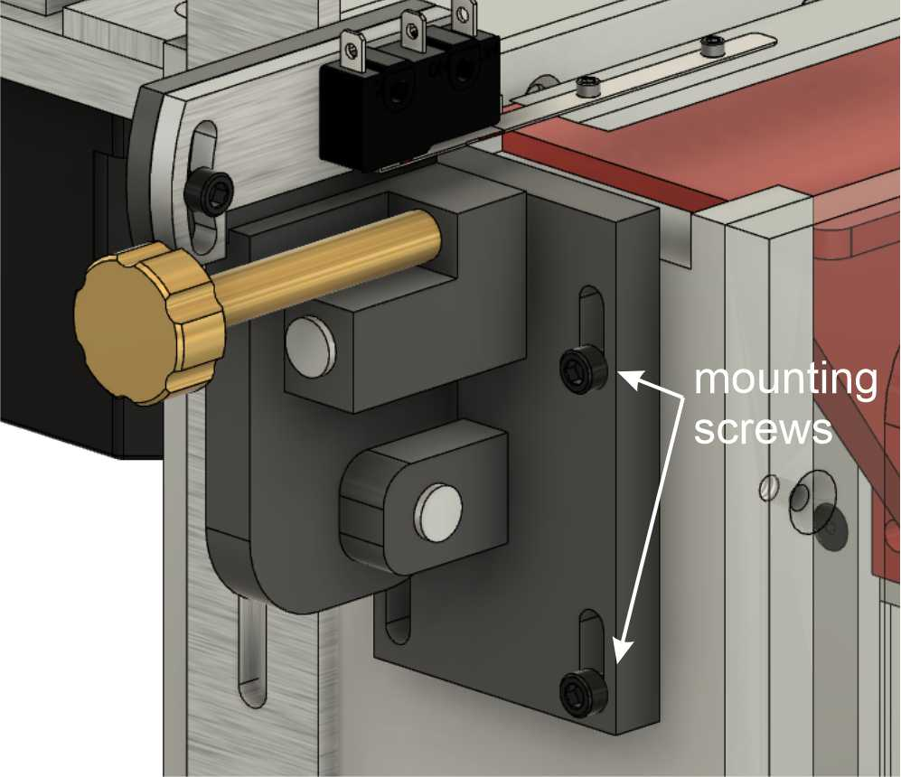The crudest adjustment is with the four mounting bolts that attach the slide detector assembly to the frame of the scanner as shown here. This will give a very gross positioning of the assembly and should be located so that the limit switch extender plate is roughly one slide with above the top of the light box.

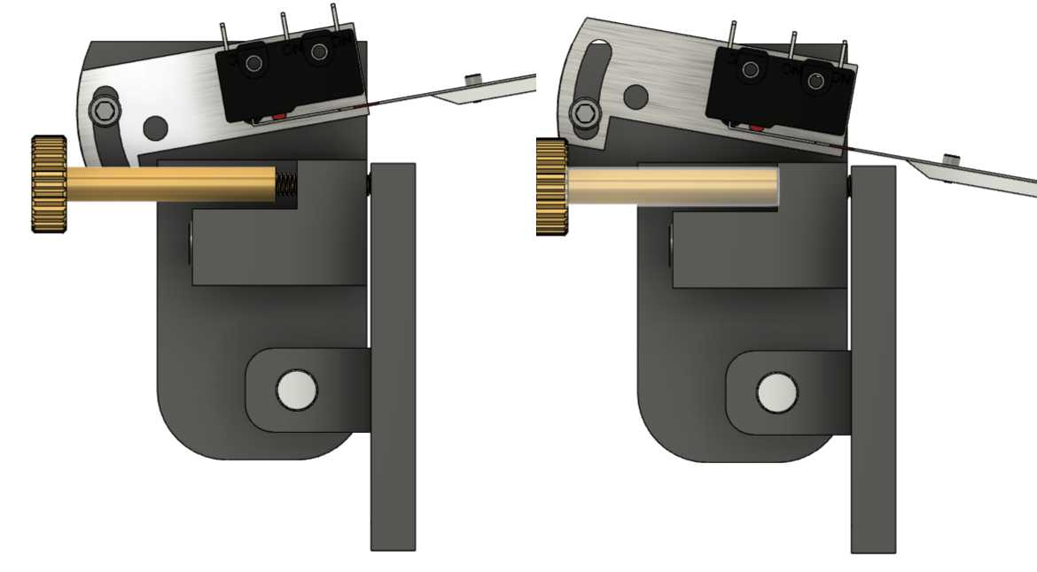Next, we can rotate the switch slightly on the switch assembly as shown here. This allows the switch to rotate plus or minus 10 degrees. The goal here is to have the extender plate senses the position of the right side of the top slide as it rises as this is the side that is in contact with the slide selection blades. This adjustment is not too critical, so positioning the switch so that it appears level is a good place to start.

Adjusting the angle of the slide detection limit switch

Crude adjustment of the slide detector switch with four cap screws in slots.

The third and most critical uses the brass knob on the switch. This switch defines how high the slide is lifted before the shuttle claw engages. Again, the goal is to have the slide lifted slightly more than 1 slide thickness above the two slide selection blades. These two If the stack moves too high, it might take two slides. If it is too low, the slide will jam against 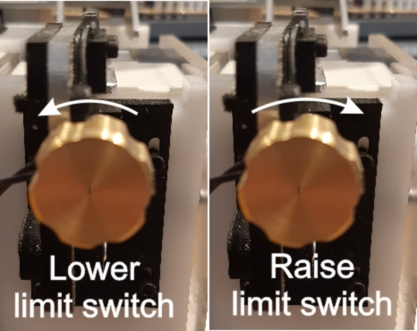the knife edges. So, it should be clear that setting this height is critical to smooth operation.

Adjustment knob for the slide detection switch offers fine control over its trigger position.

Turning this brass knob changes the activation height of the elevator limit switch. The knob works by adjusting the angle of the limit switch. Turning it clockwise will raise the slide, turning it counter clockwise will lower the slide. Once I’ve set this adjustment, I can run the scanner continuously without readjustment. However, if some slides are swollen or twisted, you may be able to scan them by playing with this knob during scanning.

# Slide Alignment Guide

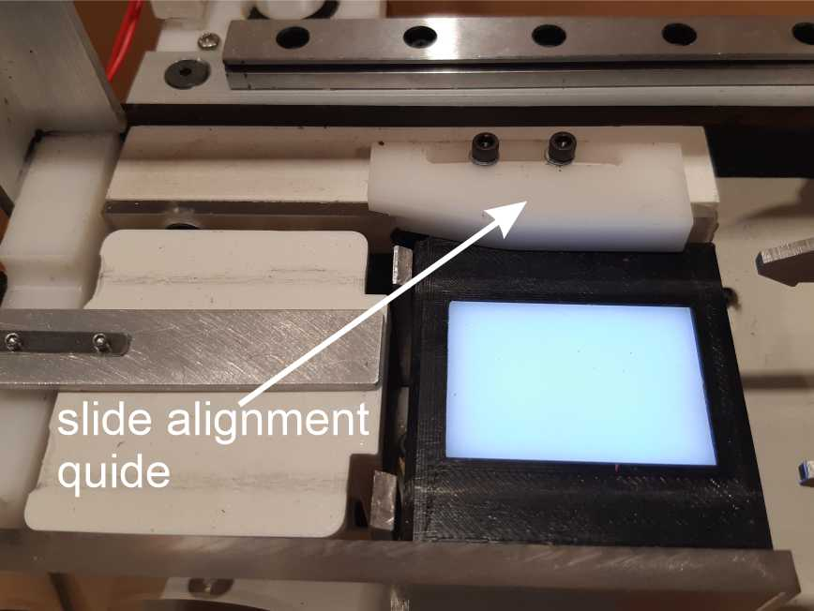The slide hopper is slightly larger than a typical 35mm slide. This was done make it easier to load the slides into the hopper. However, this means that the slides won’t form a tidy, aligned stack as the shuttle grabs the top slide and it might be slightly twisted. To fix this, I’ve added an alignment jig as shown here which straightens slides as they move over the light box. This forces the slides into a slot which is slightly larger than the slide and maintains a reproduceable position for the slide when over the light box. I have found that this helps in ensuring that each slide is projected properly when the final image is taken.

The slide alignment guide forced each slides into the narrow space over the light box. This ensures that all the slides are in the same location during digitization.

# Plastic versus Paper Slides

As mentioned, paper slides are typically more variable than plastic ones. So, some care is needed when doing these. For example, some paper slides have little fillets on their edges. These are the easiest to scan. However, some have sharp square corners, so that these corners can sometimes bind when being delivered to the light box. This is where the slide alignment guide helps to avoid any snagging of the sharp corners. However, plastic slides have their own issues. Inspect the slides and make sure that there are no little burs or edges which can get caught during delivery. It is best to orient the slides in the stack with the emulsion side face the same way. Also, try to orient the slide the same way in the left-right direction. I have found this helps prevent any binding.

# Number of Slides Scanned

I have found that I can scan a full box of plastic slides with no problem. However, paper slides can swell so that the slide on the top of the hopper may no longer be level and the entire stack of slides can be quite spongy. This may cause problems as the limit switch may be triggered at the wrong location. To deal with this I have found that inserting no more than 40 slides is best. Depending on the condition of the slides, more could be added.

# What to do if the Scanner Transport Fails

There are two ways that the transport can fail:

* Getting jammed onto the knife edges or
* Taking two slides instead of just one.

## Jammed Slides

If the claw grabs a slide and gets jammed when attempting to move it to the light box, the stepper motor will stall and make a buzzing sound. This is not damaging anything but at this point it is best to hit the reset button on the console. This will stop everything instantly. Have a look at the recalcitrant slide and see if it is warped or bent. If it is, don’t try to scan it. If is OK, then some adjustment of the slide detector switch may help. In this case, the limit switch needs to be raised which is done by rotating the knob clockwise. I would suggest turning about ¼ turn and try again. If it fails again, rotate the knob another ¼ turn. Repeat this until it works.

## Taking Two Slides instead of One

This is a result of the limit switch being too high. In this case, rotate the knob counter-clockwise ( ¼ turn at a time) until it just grabs one slide.

1. <https://www.amazon.ca/gp/product/B07D7MXWHV/ref=ppx_yo_dt_b_asin_title_o01_s00?ie=UTF8&psc=1> [↑](#footnote-ref-1)